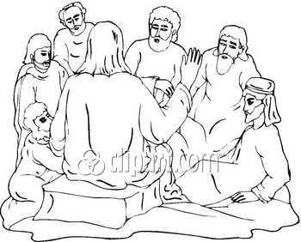

Luke 9:18-22 4th-5th Grade Class
Key verse: 20 Name: _________

Write and memorize the key verse.
____________________________________________________________________________________________________________________________________________________________________________________________________

1. What was Jesus doing? (18a) One day Jesus was praying alone. Only his disciples were with him.
____________________________________________________________________________________________________________________________________________________________________________________________________

2. What question did he ask his disciples and why? (18b) He asked them, "Who do the crowds say I am?"

____________________________________________________________________________________________________________________________________________________________________________________________________

3. What did the people of Jesus’ time believe about him? (19) They replied, "Some say John the Baptist. Others say Elijah. Still others say that one of the prophets of long ago has come back to life."

____________________________________________________________________________________________________________________________________________________________________________________________________

4. What do people of today believe about Jesus?

____________________________________________________________________________________________________________________________________________________________________________________________________

5. What did Jesus ask the disciples and why? (20a) "But what about you?" he asked. "Who do you say I am?"

____________________________________________________________________________________________________________________________________________________________________________________________________

6. What was Peter’s answer? (20b) Peter answered, "The Christ of God."

____________________________________________________________________________________________________________________________________________________________________________________________________

7. What does the word Christ mean? (John 4:25) The woman said, "I know that Messiah is coming." (He is called Christ.) "When he comes, he will explain everything to us."
____________________________________________________________________________________________________________________________________________________________________________________________________

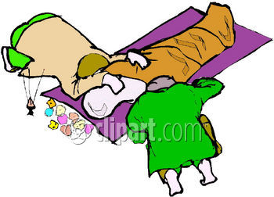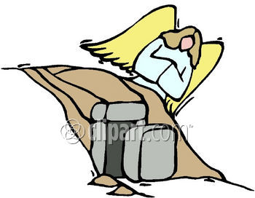

8. Why did Jesus tell them not to tell others about him? (21) Jesus strongly warned them not to tell this to anyone.

____________________________________________________________________________________________________________________________________________________________________________________________________

9. What did Jesus say must happen to him? (22) He said, "The Son of Man must suffer many things. The elders will not accept him. The chief priests and teachers of the law will not accept him either. He must be killed and on the third day rise from the dead."

____________________________________________________________________________________________________________________________________________________________________________________________________

10. Why did Jesus have to suffer so much, die and be raised again on the third day? (Romans 6:23) When you sin, the pay you get is death. But God gives you the gift of eternal life because of what Christ Jesus our Lord has done.
____________________________________________________________________________________________________________________________________________________________________________________________________

11. Who do you say Jesus is?
____________________________________________________________________________________________________________________________________________________________________________________________________

12. What has Jesus Christ done for you?
____________________________________________________________________________________________________________________________________________________________________________________________________

____________________________________________________________________________________________________________________________________________________________________________________________________________________________________________________________________________________________________________________________________________________________________________________________________________________________________________________________________________________________________________________________________________________________________________________________________________________________________________________________________________________________________________________________________________________________________________________________________________________________________________________________________________________________________________________________________________________________________________________________________________________________________________________________________________________________________________________________________________________________________________________________________________________________________________________________________________________________________________________________________________________________________________________________________________________________

