Praise the LORD
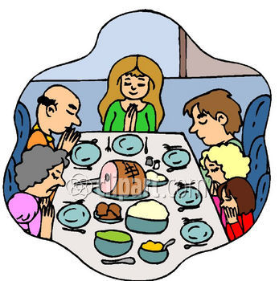

Psalm 103:1-5 2rd-3th Grade Class
Key verse: 2 Name: _________

Write and memorize the key verse.

____________________________________________________________________________________________________________________________________________________________________________________________________

Thank you Jesus!

Thank you Jesus!
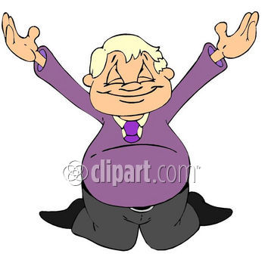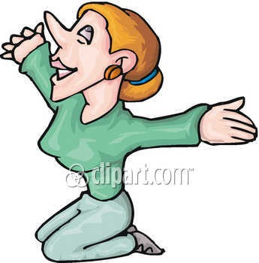
Praise the LORD (1)

1. What does David tell himself to do? (1a) Praise the LORD, O my soul;

A. David told himself to do his homework B. David told himself to clean his room C. David told himself to praise the LORD D. None of the answers are correct

2. Why do we have to tell ourselves to praise the LORD?
____________________________________________________________________________________________________________________________________________________________________________________________________

3. How should we praise the LORD? (1b) All my inmost being, praise his holy name.

A. We should praise the LORD a little bit B. We should praise the LORD with everything we have C. We should praise the LORD with some of what we have D. None of the answers are correct

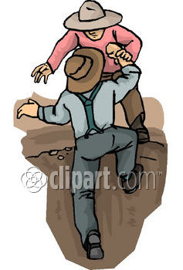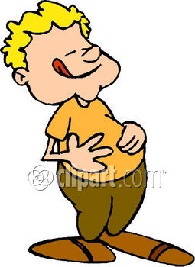
The LORD'S Benefits (2-5)

4. What should we remember and not forget? (2) Praise the LORD, O my soul, and forget not all his benefits—

____________________________________________________________________________________________________________________________________________________________________________________________________

5. Matching: The LORD’S Benefits. Match the picture to the verses. (3-5a)

___ A. “who forgives all your sins”
____ B. “who satisfies your desires with good things”
____ C. “crowns you with love”
____ D. ”redeems your life from the pit”

____ E. ”heals all your diseases”

6. What happens when we remember the LORD and his benefits? (5b) so that your youth is renewed like the eagle’s.

A. We become strong and graceful like an eagle B. We become weak and clumsy like a chicken C. Nothing happens to us D. None of the answers are correct

7. How can you celebrate this thanksgiving?

____________________________________________________________________________________________________________________________________________________________________________________________________

____________________________________________________________________________________________________________________________________________________________________________________________________________________________________________________________________________________________________________________________________________________________________________________________________________________________________________________________________________________________________________________________________________________________________________________________________________

