Paul Lee

**2015 Best Moments in Geneva UBF**

Key verse: Revelation 5:8 – **“Each one had a harp and they were holding golden bowls full of incense, which are the prayers of God’s people.”**

1. **God blessed a wish of a children**

At the 2015 European Coordinators Conference in Switzerland, Msn Mateus Singh’s family attended. As Portugal is warm country, Lydia Jr. Singh never could have seen the snow falling. Coming to Switzerland, she had one wish. It was seeing the snow falling. At that time the weather was sunny in Switzerland. However from the 27th December the beginning of the conference, the snow began to fall a lot. Snow fell during two days in Interlaken and the world became all white. Lydia and all the children who attended the conference have made a big snowman. A lot of children in the Alps too were enjoying the snow riding a ski. We learned that God is merciful Father who fulfills wishes of children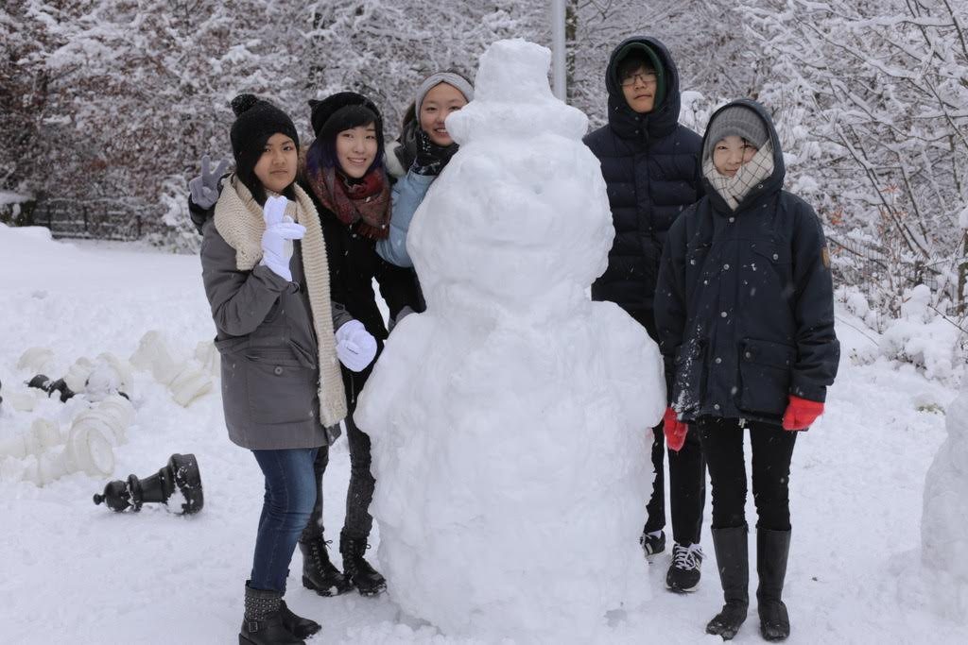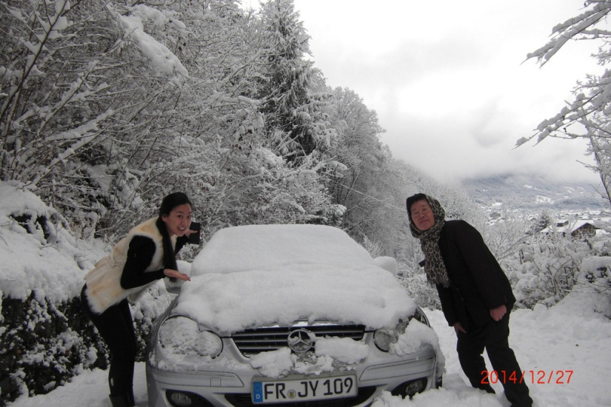.

1. **God, who stopped the snow December 29, the end of the conference.**

Throughout the conference days, tremendous snows fell by the blessing of God. Children enjoyed it so much, but adults started to worry saying “When the snow will stop!” Because from the December 29, around 50 people would go back to the mission field and the other 50 people had a plan to go to the Jungfrau.

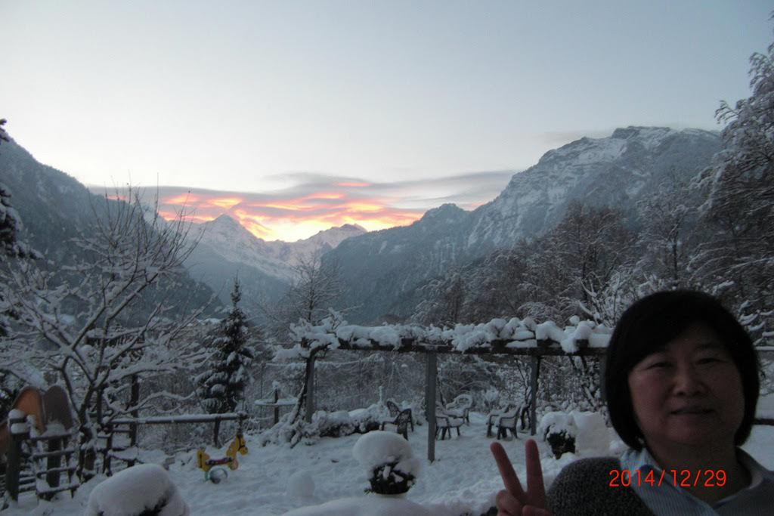During the night of December 28th, missionary Sarah prayed for a clear weather, commanding in the name of Jesus. «Stop snow! Clear weather comes! » When I got up at 5 am December 29th, the snow was completely stopped and looked at one bright morning star. At 10am we saw the majestic Jungfrau. Oh, God, you are great, so cool, and beautiful. It was a real joy to work with God. We learned that when we co-work with this God, there will be no big difficulty.

1. **God loves our second generation and meets them.**

Paul Jr. attended youth conference in Nantes, France from April 23th to 27th. Sarah Jr passed two months in Korea staying at Kwanak III UBF and received a lot of love and prayer. Paul Jr. is studying well this year at Geneva University. Sarah Jr. graduated Art School with honors and received the awards. Praise God! He loves children and meets them personally.

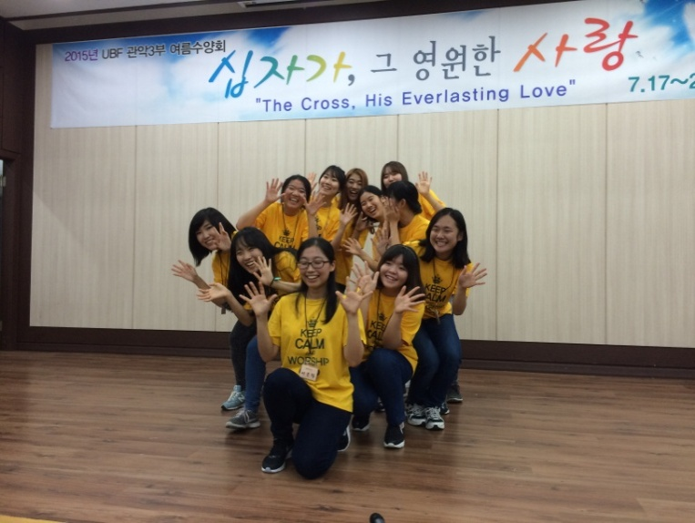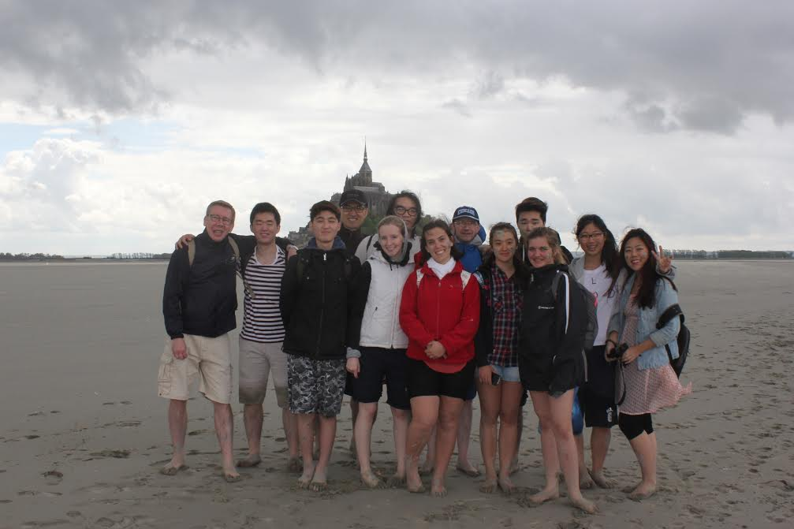

1. **God led my brother-in-law to Jesus.**

My family visited Korea from July 6th for 20 days. It was to help Sarah Jr. to understand Korea and to strengthen our families in Korea with the Word of God. We relied on Hebrews 1: 3, "sustaining all things by his powerful word." While visiting my families and missionary Sarah’s family during 2 weeks, we celebrated 12 times worships service together. In particular, we had a plan to help my brother-in-law who did not meet Jesus. Lotte Department Store in Yeongdeungpo was supposed to meeting place for lunch, we prayed to God to give us a quiet place. But inside of the Department store was too loud, there was no place to talk quietly and pray. That day, the weather was so hot; no one was on the roof outside of the Department Store. But we found a small shady corner of the roof; the wind blew gently only there. We 4 persons sited down there. My brother-in-law began to give his testimony of his new life in Jesus. He studied Bible with two pastors and he was active to worship and to praise. He was also a dedicated volunteer for the service of homeless peoples. Missionary Sarah and I shed tears while listening to his testimony.

Our intercession prayer in Switzerland far from Korea seemed to be nothing, but really God leaded brother-in-law to Jesus. It was wonderful and marvelous to us. We shared together Word of God, sang a song together and prayed on the roof of the Lotte Department Store. God is truly living. He listens to our intercession prayer.

1. **Kiental Alps Weekend Retreat from November 20 to 22**

We prayed from the 2 months before for this conference. We prayed that the Holy Spirit prepare everything, invite us, give the Word and give foods to eat. One week before the conference, a brother asked. "Are the conference preparations going well?” So I answered. "Yes, God prepares everything well. He is doing invitation; He will give the word. He will give “Bab” (rice food) to eat. He will also give children’s program. As our God is host of this conference, we have nothing to do.” The brother laughed. So I laughed. We believed that this time God is the host and we are invited. We only accepted his invitation, prayed and we had not something special to prepare. Missionary Sarah received a Word from God. “Everything is possible for one who believes.” Since then we enjoyed the joy and peace.

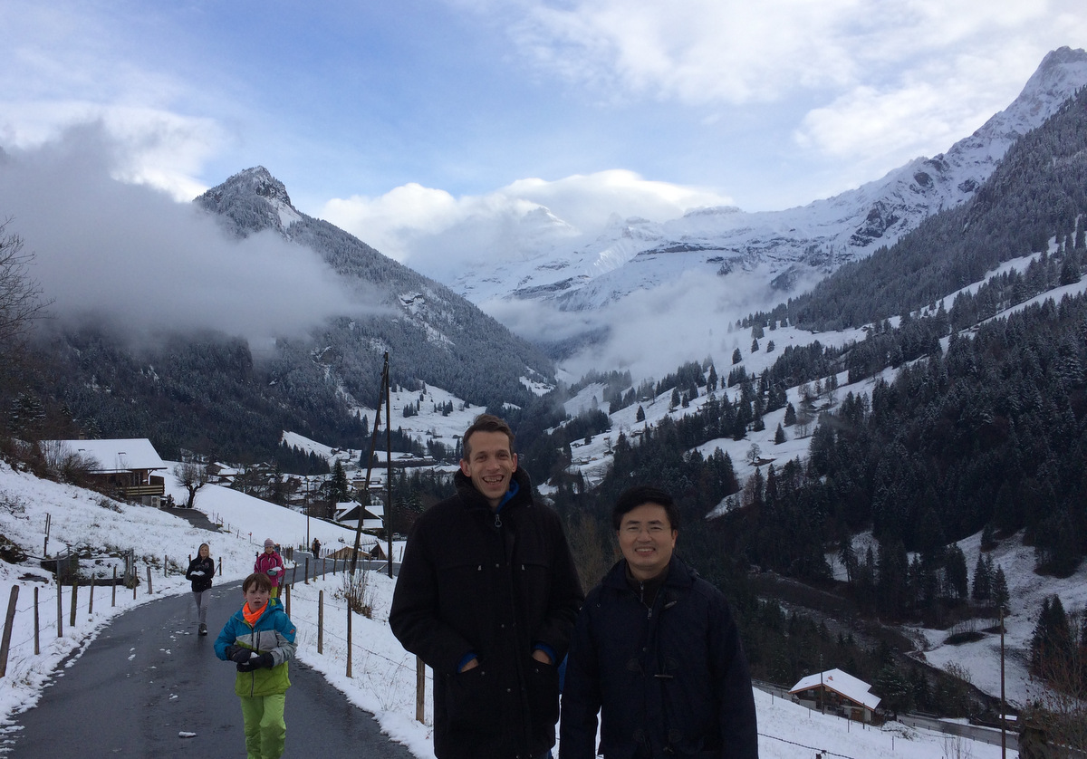

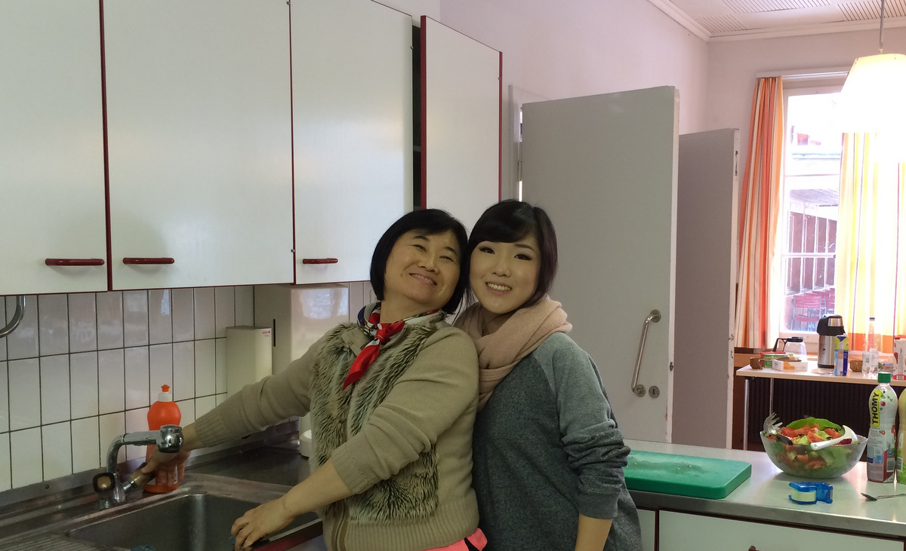

From the beginning of the conference November 21, our Lord sent the first snow of the year 2015. Snow was falling, children was making snowmen, enjoyed snowball fights. There are no better children program than making snowmen and enjoying a snowball fights. Jesus gave us during 3 days his word and we were fortified. A brother said he was miraculously encouraged. Foods was abundant, after the conference, we distributed remain foods with several shopping bags. Even though it was a short weekend conference, we all have got the healing of the heart and were fortified. Resting in the Holy Spirit without hard work, we were able to help others with the word of God. The cost of the conference was free as we were invited by the Holy Spirit. But everyone did offering. A brother did offering of 1000 Swiss francs, so all conference expenses were covered. Hallelujah.

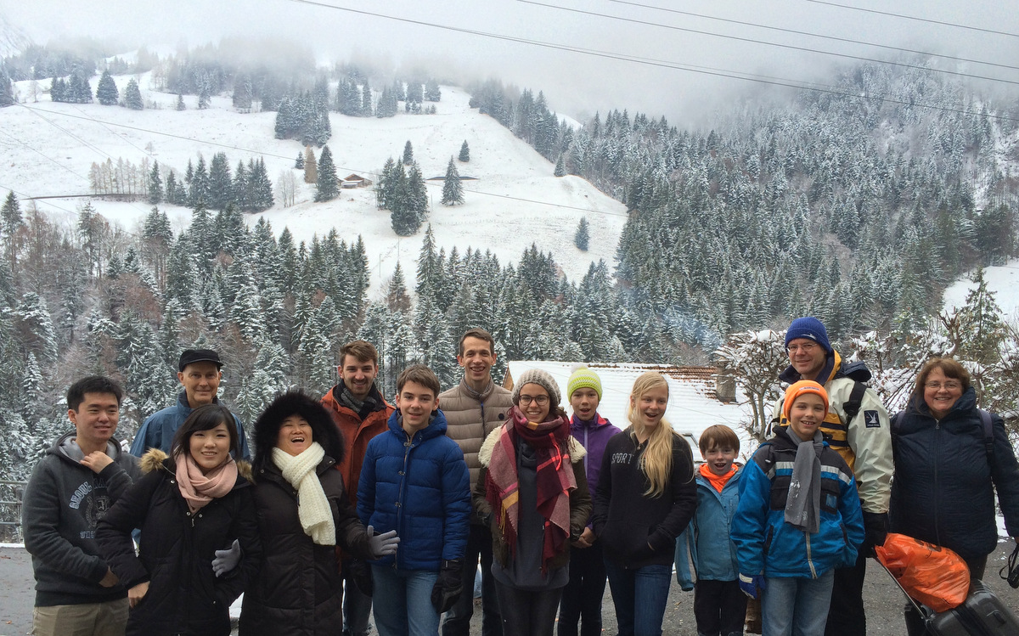

1. **From April to November, we shared Word of God with 32 missions co-workers through email greeting.**

In all the epistles of the New Testament, the Apostle Paul recommended to give greetings to each church together. So we gave 18 times greetings to 32 mission co-workers including French missionaries.

|  |  |
| --- | --- |
| April 7 > Jesus died. Jesus was raised. | April 9 > God’s promise in the last days. |
| April 14 > Samaritan woman’s question and Jesus’ answer. | April 21 > My portrait |
| April 22 > Angel of Paris | April 23 > Holy Spirit, come and help us. |
| April 24 > 3 things stolen, 3 things to get back. | April 27 > This early morning, an angel tickled my armpit. |
| April 29 > fellowship with Holy Spirit | May 1 > 5 breads and 2 fishes, thank you, share, miracle. |
| May 7 > fear, voice, word, peace, faith, hope, love. | June 9 > by the word of God |
| July 28 > Korean journey report | September 14 > Muslim refugees, work of Holy Spirit |
| October 22일 > Demitry & Isabelle mariage news | November 4 > Golden bowl, incense of prayer. |
| November 13 > Sit down, please sit down. | November 26 > Conference news |

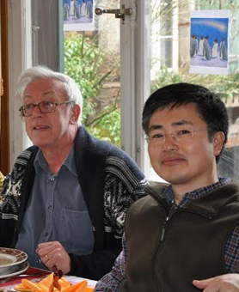

1. **Holy Spirit with us through the Word.**

God blessed my morning Bible lecture before going to work. I read the whole Bible last year and the Lord gave word and direction whenever needed. Over a year and a half, only by the Holy Spirit's help I studied the 66 books of the Bible with a brother. We did an essential study a book once a week. We got a lot of encouragement and gained more confidence in the Bible study.

1. **God gave for a long time an autumn really warm and splendid.**

It was the first time in Switzerland for me that 2015’s year autumn was so great. I said often. «Here there is no real autumn. I miss the beautiful autumn of Korea. If I visit Korea, I want to go in an autumn season.» But the 2015 Swiss autumn was so colorful and it was so happy season. It looked much nicer than the Korean fall. Thank God. This year’s fall was so good, why? People say that it is strange temperature, the effect of global warming. But the next answer from missionary Sarah would be the right one. «Now a lot of Syrian refugees are coming to Europe. The weather is warm because God wants to give time to them to find a place where they live. He gives time to Europe to prepare a place to welcome them.» I replied “oh, you're so right.” Praise our merciful God.

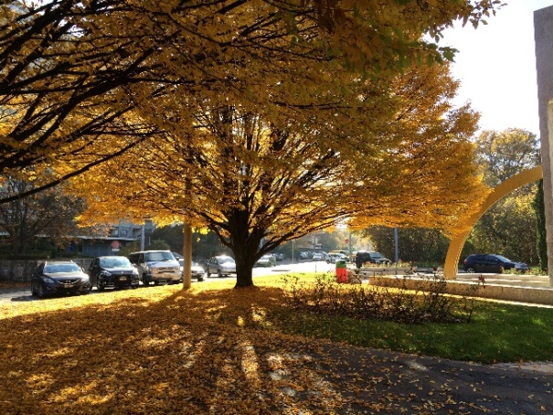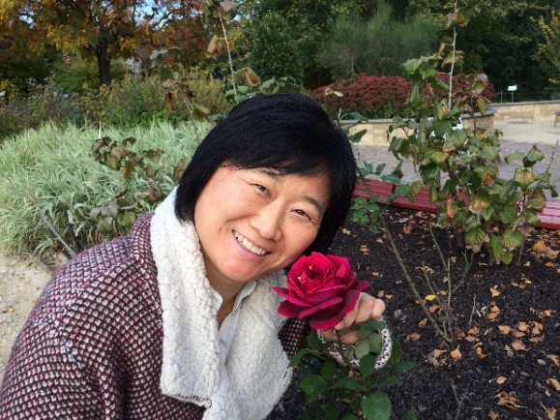

1. **God gave us the grace through early morning prayer and praise.**

2015 year was a particularly difficult year for many things in the company work. But the Holy Spirit helped us to pray and praise in the church’s basement near the house in the early morning. Last year sometimes we were sad, lonely, surprised, difficult, angry, worried, tired, passed unsleeping days. But through the prayer and praise, we enjoyed the comfort and peace, received power and word. It was the precious time to praise God and meet Jesus and the Holy Spirit. Especially I praised Jesus’ blood, and throughout the year, I sang a Christmas song, I tasted the peace of Christmas throughout the year. Hallelujah.

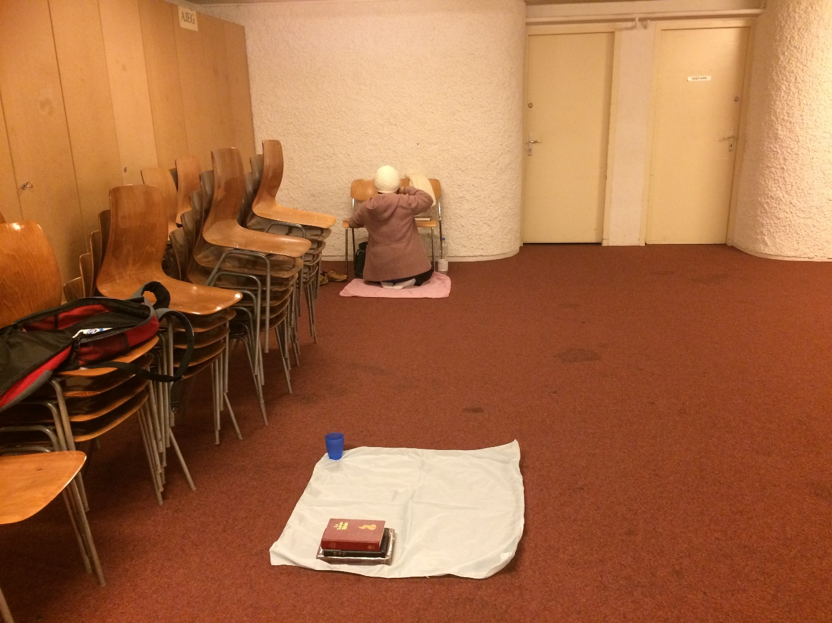

Key verse 2016: “Each one had a harp and they were holding golden bowls full of incense, which are the prayers of God’s people.” (Revelation 5:8)

In 2016, we would like to be filled with the Holy Spirit through prayer and praise. We want to obey with an absolute attitude to the Holy Spirit and have a fellowship with Jesus and be used as a servant of word of God.

One word: Let’s wish be filled with the Holy Sprit

Other 2015 Photos souvenir

|  |  |
| --- | --- |
| 2015 European coordinators conference in Switzerland | |
| Shepherd Ordination of Marian Blessing from Bern UBF | Dr. Jochebed Oh from Hamburg |
| Family Msn. Espérance Kim from Paris UBF | Shep. Abraham Chung from YulJun UBF |
| Marriage of brother Demitry | Marriage of Demitry and Isabelle |
| With my brother at his company | Sarah Jr. Graduation Ceremony |
| Father and Son at Mt. Mont Blanc |  |