The Story of the Lost Son

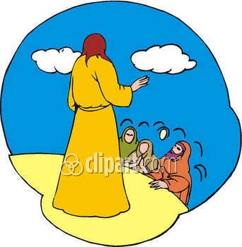

Luke 15:11-32 2nd-3rd Grade Class

Key verse: 32 Name: _________

Write and memorize the key verse.

____________________________________________________________________________________________________________________________________________________________________________________________________



1. What did the father do for his younger son? (11-12) Jesus continued, "There was a man who had two sons. ¹² The younger son spoke to his father. He said, 'Father, give me my share of the family property.' So the father divided his property between his two sons.

____________________________________________________________________________________________________________________________________________________________________________________________________

2. What did the younger son do with what his father gave him? (13-14a) "Not long after that, the younger son packed up all he had. Then he left for a country far away. There he wasted his money on wild living. ¹⁴ He spent everything he had.

____________________________________________________________________________________________________________________________________________________________________________________________________
3. What happened to the younger son when all his money was gone (14b-15) "Then the whole country ran low on food. So the son didn't have what he needed. ¹⁵ He went to work for someone who lived in that country, who sent him to the fields to feed the pigs. ¹⁶ The son wanted to fill his stomach with the food the pigs were eating. But no one gave him anything.

____________________________________________________________________________________________________________________________________________________________________________________________________

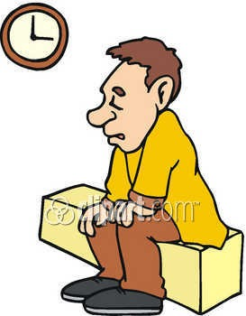
4. What did the younger son decide to do? (17-20a) "Then he began to think clearly again. He said, 'How many of my father's hired workers have more than enough food! But here I am dying from hunger! ¹⁸ I will get up and go back to my father. I will say to him, "Father, I have sinned against heaven. And I have sinned against you. ¹⁹ I am no longer fit to be called your son. Make me like one of your hired workers." ' ²⁰ So he got up and went to his father.

____________________________________________________________________________________________________________________________________________________________________________________________________
5. How did the father welcome his son back? (20b) "While the son was still a long way off, his father saw him. He was filled with tender love for his son. He ran to him. He threw his arms around him and kissed him.
____________________________________________________________________________________________________________________________________________________________________________________________________

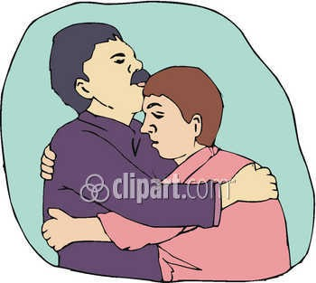
6. How did the father welcome his son back? (21-24) "The son said to him, 'Father, I have sinned against heaven and against you. I am no longer fit to be called your son.' ²² "But the father said to his servants, 'Quick! Bring the best robe and put it on him. Put a ring on his finger and sandals on his feet. ²³ Bring the fattest calf and kill it. Let's have a big dinner and celebrate. ²⁴ This son of mine was dead. And now he is alive again. He was lost. And now he is found.' "So they began to celebrate.

____________________________________________________________________________________________________________________________________________________________________________________________________

7. What did the older brother do? (25-30) "The older son was in the field. When he came near the house, he heard music and dancing. ²⁶ So he called one of the servants. He asked him what was going on. ²⁷ " 'Your brother has come home,' the servant replied. 'Your father has killed the fattest calf. He has done this because your brother is back safe and sound.' ²⁸ "The older brother became angry. He refused to go in. So his father went out and begged him. ²⁹ "But he answered his father, 'Look! All these years I've worked like a slave for you. I have always obeyed your orders. You never gave me even a young goat so I could celebrate with my friends. ³⁰ But this son of yours wasted your money with some prostitutes. Now he comes home. And for him you kill the fattest calf!'

____________________________________________________________________________________________________________________________________________________________________________________________________

8. Why was the father so happy? (31-32) " 'My son,' the father said, 'you are always with me. Everything I have is yours. ³² But we had to celebrate and be glad. This brother of yours was dead. And now he is alive again. He was lost. And now he is found.' "

A. The father loved his son very much
B. The son was spiritually dead and now was spiritually alive C. The son was lost, but now was found
D. All the answers are correct

9. What can we learn about God’s love for lost sinners? (15:10) "I tell you, it is the same in heaven. There is joy in heaven over one sinner who turns away from sin."
____________________________________________________________________________________________________________________________________________________________________________________________________


___________________________________________________________________________________________________________________________________________________________________________________________________________________________________________________________________________________________________________________________________________________________________________________________________________________________________________________________________________________________________________________________________________________________

