Luke 16:19-31 2nd-3rd Grade Class
Key verse: 31 Name: _________
5/1/11

Write and memorize the key verse.

____________________________________________________________________________________________________________________________________________________________________________________________________
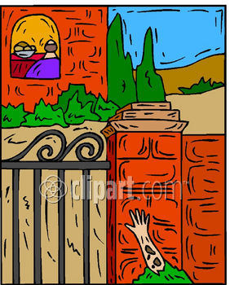

1. Who was the first man and how did he live? (19) Once there was a rich man. He was dressed in purple cloth and fine linen. He lived an easy life every day.

A. He was a rich man so he had a lot of money B. He had nice clothes to wear all the time C. He had plenty of things all the days of his life and was happy D. All the answers are correct

2. Who was Lazarus and how did he live? (20-21) A man named Lazarus was placed at his gate. Lazarus was a beggar. His body was covered with sores. 21 Even dogs came and licked his sores. All he wanted was to eat what fell from the rich man's table.

A. Lazarus had nothing and had to beg for everything B. He was very sick and had painful sores all over his body C. He was so hungry and wanted to eat the rich man’s leftovers D. All the answers are correct
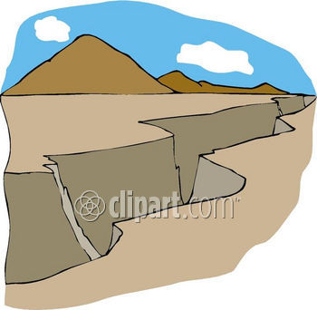
3. True/False: Read the verses. If the sentence is true put a T in the blank, if it is false put an F. Change all false sentences to make them true. (22-23) The time came when the beggar died. The angels carried him to Abraham's side. The rich man also died and was buried. 23 In hell, the rich man was suffering terribly. He looked up and saw Abraham far away. Lazarus was by his side.24 So the rich man called out, 'Father Abraham! Have pity on me! Send Lazarus to dip the tip of his finger in water. Then he can cool my tongue with it. I am in terrible pain in this fire.' 25 "But Abraham replied, 'Son, remember what happened in your lifetime. You received your good things. Lazarus received bad things. Now he is comforted here, and you are in terrible pain.

___ The rich man and Lazarus both died.

___ The rich man went to paradise.

___ Lazarus went to hell.
4. What happens after death? (26; Hebrews 9:27) Besides, a wide space has been placed between us and you. So those who want to go from here to you can't go. And no one can cross over from there to us.' Hebrews 9:27 People have to die once. After that, God will judge them.
____________________________________________________________________________________________________________________________________________________________________________________________________



5. Why did Lazarus the beggar go to paradise? (27-29) "The rich man answered, 'Then I beg you, father. Send Lazarus to my family. 28 I have five brothers. Let Lazarus warn them. Then they will not come to this place of terrible suffering.' 29 "Abraham replied, 'They have the teachings of Moses and the Prophets. Let your brothers listen to them.'

A. Lazarus believed the teachings of Moses B. Lazarus believed the teachings of the Prophets C. Lazarus believed teachings of the Bible D. All the answers are correct

6. Why did the rich man go to hell? (30) " 'No, father Abraham,' he said. 'But if someone from the dead goes to them, they will turn away from their sins.'

____________________________________________________________________________________________________________________________________________________________________________________________________
7. What did Abraham say to the rich man? (31) "Abraham said to him, 'They do not listen to Moses and the Prophets. So they will not be convinced even if someone rises from the dead.' "

____________________________________________________________________________________________________________________________________________________________________________________________________

8. What are the main teachings of scripture that people need to believe? (31, 1 Corinthians 15:3-4) What I received I passed on to you. And it is the most important of all. Here is what it is. Christ died for our sins, just as Scripture said he would. 4 He was buried. He was raised from the dead on the third day, just as Scripture said he would be.

____________________________________________________________________________________________________________________________________________________________________________________________________

___________________________________________________________________________________________________________________________________________________________________________________________________________________________________________________________________________________________________________________________________________________________________________________________________________________________________________________________________________________________________________________________________________________________

