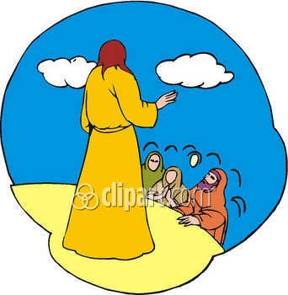

Luke 13:22-30 4th-5th Grade Class

Key verse: 24 Name: __________

Write and memorize the key verse.

____________________________________________________________________________________________________________________________________________________________________________________________________


1. What question did someone ask Jesus? (22-23a) Then Jesus went through the towns and villages, teaching the people. He was on his way to Jerusalem. ²³ Someone asked him, "Lord, are only a few people going to be saved?"

__________________________________________________________________________________________________________________________________________________________________________________________________

2. What did Jesus teach about the way to be saved? (23b, 24) He said to them, ²⁴ "Try very hard to enter through the narrow door. I tell you, many will try to enter and will not be able to.

A. Being saved is like entering through a narrow door
B. We must try very hard to enter through the narrow door and be saved
C. Many will try to enter through the narrow door and will not be able to.
D. All the answers are correct
3. What will happen when the narrow door is closed? (25)
The owner of the house will get up and close the door. Then you will stand outside knocking and begging. You will say, 'Sir, open the door for us.' "But he will answer, 'I don't know you. And I don't know where you come from.'

____________________________________________________________________________________________________________________________________________________________________________________________________

4. What excuses will the people outside make? (26) ²⁶ "Then you will say, 'We ate and drank with you. You taught in our streets.'

____________________________________________________________________________________________________________________________________________________________________________________________________

5. True or False. Read verse 27. Mark each statement with “T” for True or “F” for False. Change all false statements to make them true. (27) "But he will reply, 'I don't know you. And I don't know where you come from. Get away from me, all you who do evil!'

___ God knows those on the outside.

___Those on the outside know God.

___ God doesn’t know where those on the outside come from.

___ Those on the outside can still come to God.

___Those on the outside do evil

6. What will it be like for those outside the kingdom of God? (28) "You will sob and grind your teeth when you see those who are in God's kingdom. You will see Abraham, Isaac and Jacob and all the prophets there. But you yourselves will be thrown out.

____________________________________________________________________________________________________________________________________________________________________________________________________

7. Who will be in the kingdom of God? (28b, 29)
when you see Abraham, Isaac and Jacob and all the prophets in the kingdom of God, 29 People will come from east and west and north and south, and will take their places at the feast in the kingdom of God.
____________________________________________________________________________________________________________________________________________________________________________________________________




