The Good Samaritan

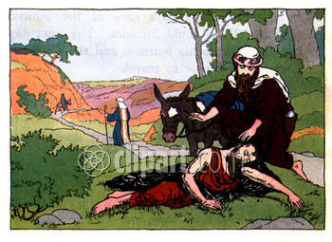

Luke 10:25-37 2nd-3rd Grade Class
Key verse: 37 Name: __________

Write and memorize the key verse.

____________________________________________________________________________________________________________________________________________________________________________________________________

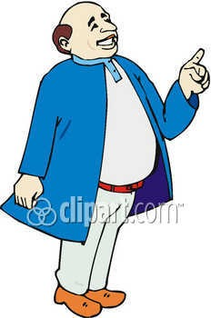

1. What question did the lawyer ask Jesus? (25) One day an authority on the law stood up to put Jesus to the test. "Teacher," he asked, "what must I do to receive eternal life?"

A. He asked Jesus how to become his disciple
B. He asked Jesus what is the greatest commandment
C. He asked Jesus what to do to receive eternal life
D. None of the answers are correct

2. How did Jesus answer the lawyer’s question? (26) "What is written in the Law?" Jesus replied. "How do you understand it?"
A. Jesus answered him with a two more questions
B. Jesus wanted to know the lawyer’s opinion
C. Jesus asked him what he understood from the word of God
D. All the answers are correct

3. What Bible verse did the lawyer quote? (27) He answered, " 'Love the Lord your God with all your heart and with all your soul. Love him with all your strength and with all your mind.'—(Deuteronomy 6:5) And, 'Love your neighbor as you love yourself.' "—(Leviticus 19:18)

A. Leviticus 19:18
B. A Bible verse about how to love God
C. A Bible verse about how to love others
D. All the answers are correct

4. True/False: Read the verses. If the sentences are true put a T in the blank and an F if they are false. (28-29)
"You have answered correctly," Jesus replied. "Do that, and you will live." ²⁹ But the man wanted to make himself look good. So he asked Jesus, "And who is my neighbor?"

___ The lawyer answered was correctly

___ If the lawyer obeys Leviticus 19:18 he will have eternal life

___ The lawyer had no other questions

___ The lawyer asked, “Who is my neighbor?”, because he wanted to make himself look good

5. Retell Jesus’ story in your own words (30-35) ³⁰ Jesus replied, "A man was going down from Jerusalem to Jericho. Robbers attacked him. They stripped off his clothes and beat him. Then they went away, leaving him almost dead. ³¹ A priest happened to be going down that same road. When he saw the man, he passed by on the other side. ³² A Levite also came by. When he saw the man, he passed by on the other side too. ³³ But a Samaritan came to the place where the man was. When he saw the man, he felt sorry for him. ³⁴ He went to him, poured olive oil and wine on his wounds and bandaged them. Then he put the man on his own donkey. He took him to an inn and took care of him. ³⁵ The next day he took out two silver coins. He gave them to the owner of the inn. 'Take care of him,' he said. 'When I return, I will pay you back for any extra expense you may have.'

_____________________________________________________________________________________________________________________________________________________________________________________________________________________________________________________________________________________________________
7. Who was truly a neighbor to this man? (36-37a) "Which of the three do you think was a neighbor to the man who was attacked by robbers?" ³⁷ The authority on the law replied, "The one who felt sorry for him."

A. The Samaritan B. The Levite C. The Priest

8. Why did Jesus tell this man to go and do as he did? (37b) Jesus told him, "Go and do as he did."

____________________________________________________________________________________________________________________________________________________________________________________________________



_____________________________________________________________________________________________________________________________________________________________________________________________________________________________________________________________________________________________________________________________________________________________________________________________________________________________________________________________________________________________________________________________________________________________________________________________________________________________________________________________

