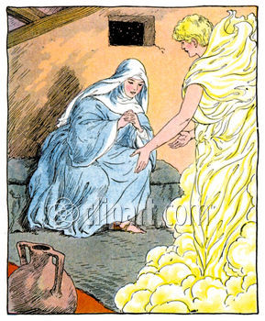

12/12/10
Luke 1:26-38 2nd-3rd Grade Class
Key verse: 38 Name: __________

Write and memorize the key verse.

____________________________________________________________________________________________________________________________________________________________________________________________________

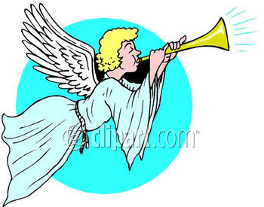

1. Who told Mary the good news? (26) In the sixth month, God sent the angel Gabriel to Nazareth, a town in Galilee,

A. The doctor told Mary the good news B. The angel Gabriel told Mary the good news C. Joseph told Mary the good news D. None of the answers are correct

2. What kind of woman was Mary? (27-28) to a virgin pledged to be married to a man named Joseph, a descendant of David. The virgin’s name was Mary. 28 The angel went to her and said, “Greetings, you who are highly favored! The Lord is with you.”

A. She was engaged to marry Joseph B. She was a pure woman and never had a boyfriend C. She was highly favored by God D. All the answers are correct

3. True/False: Read the sentence and put a T in the blank if it is true and an F if it is false. Change all false statements to make them true. (29-33) Mary was greatly troubled at his words and wondered what kind of greeting this might be. 30 But the angel said to her, “Do not be afraid, Mary, you have found favor with God. 31 You will be with child and give birth to a son, and you are to give him the name Jesus. 32 He will be great and will be called the Son of the Most High. The Lord God will give him the throne of his father David, 33 and he will reign over the house of Jacob forever; his kingdom will never end.”

___ Mary was greatly troubled when she saw the angel.

___ The angel told Mary that she would give birth to a daughter.

___ The child’s name was to be Joseph Junior.

___ The child would be the Son of the Most High.

___ He would sit on David throne and rule over all forever.
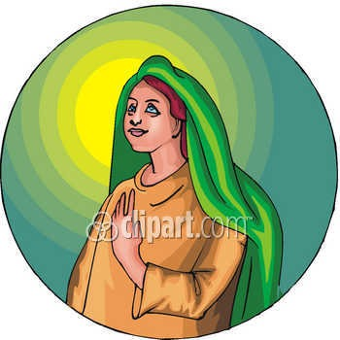

4. What Mary not sure about? (34) “How will this be,” Mary asked the angel, “since I am a virgin?”

____________________________________________________________________________________________________________________________________________________________________________________________________

5. What did the angel explain to Mary? (35) The angel answered, “The Holy Spirit will come upon you, and the power of the Most High will overshadow you. So the holy one to be born will be called the Son of God.

A. The Holy Spirit would come upon Mary B. The power of God would cause her to become pregnant C. The child would be the holy Son of God. D. All the answers are correct

6. What did Mary do? (38) “I am the Lord’s servant,” Mary answered. “May it be to me as you have said.” Then the angel left her.

____________________________________________________________________________________________________________________________________________________________________________________________________

7. Why is it important to learn about the mother of Jesus? (Hebrews 2:14a) Since the children have flesh and blood, he too shared in their humanity.

____________________________________________________________________________________________________________________________________________________________________________________________________

_____________________________________________________________________________________________________________________________________________________________________________________________________________________________________________________________________________________________________________________________________________________________________________________________________________________________________________________________________________________________________________________________________________________________________________________________________________________________________________________________

